**Step 1: Empathize**

**Identify your client and the purpose of your website, who is your target audience?**

* My client is George Furst. A professor that I know from Korea that enjoys hiking and canoe.
* A quote from the client “My ideal is to have a website that would come up if a foreigner googles mountains of Korea or something similar. I also plan, as I said yesterday, to do a similar project on canoeing the rivers of Korea. They are a wonderful resource for recreation that is terribly underutilized.”
* The purpose of the website is therefore to help people, especially foreigners living in Korea to find out more about Korean mountains and rivers.
* It was also mentioned that in the future he wants to write a book about his experiences of hiking and canoeing in Korea. Therefore, will also have some information about him
* He is part of a group of foreigner hiking group and would also like to promote this group on his site

**Relevant Implications**

* **Aesthetics**
  + Navbar should sit on top of the page and the links should sit either on the left/right-hand side of the logo or menu
  + Have a clear contrast of front e.g. white background with black font
  + Keep the design minimal, use white space to ensure the design is not cluttered
  + Rule of thirds - the top third should contain the nave bar and dominant image; the main section should be your content and the last sections should contain a footer with copyright info and links.
  + The font should be scalable so that I easy to read across devices.
* **Accessibility**
  + Make sure your page can scale across multiple devices e.g. tablet, PC and phone using media queries
  + Use alt tags on image for blind people
  + Meta tags in the head section, give a decent description so the search engines   your site
  + Hyperlinks should be obvious, have hover effects of some kind and should work
* **Future Proofing and sustainability**
  + Code comments to help future coders understand your code
  + Use DIV tag rather than HTML5 tags to ensure a consistent and accurate design
  + CSS3 is the most up to date style sheet
  + Avoid using plugins
  + In the footer, note the year the site was created and by whom so users know it is up to and can contact you
  + Keep updating content to ensure that your information is correct
  + Designing the website for chrome and Firefox and these are the most popular browser by a large margin<http://gs.statcounter.com/browser-market-share> this will allow it to work in as many browsers as many other browsers such as opera and brave browsers use chromium as the rendering engine and therefore will display the website in the same way as it will in chrome.(cannot test for safari) As edge is being updated by Microsoft to use chromium as the rendering engine <https://www.xda-developers.com/microsoft-chromium-based-browser-replace-edge/>there is no need to design the page so that is everything works in edge as it is being updated to use the same rendering engine as chrome and therefore soon if it works in chrome it will work in edge.

**Client specifications**

* Home page with general information and about me section
* Hiking page with each mountain getting its own sub-page
* Canoeing page with each river getting its own sub-page
* A page with information about his hiking group
* Responsive design for desktop and mobile
* Use of the provided photos

**Step 2: Define**

**s**

index.html

canoeing.html

mountain.html

about_us.html

(1 page for each mountian).html

(1 page for each river).html

**Evidence of written permission**



**management of files**

within my folder I added the 4 main html pages and my CSS file for all the sites. I then created a folder for the multiple canoeing html pages and mountains html pages I will have in order to not have 20+ html files all in one folder

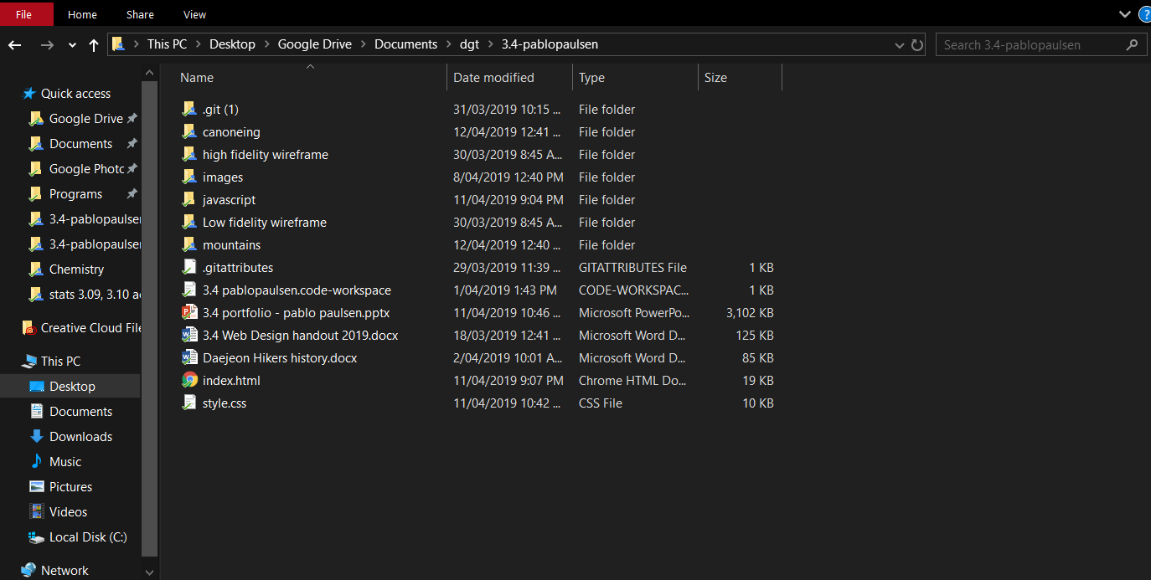

**Images**

* All of my photos for index and Daejeon hikers page will go straight in to my images folder. However, in order to not have 1000s of unorganized photos each page about each mountain and river will get its own folder.
* In order to load the page as fast as possible I used googles <https://squoosh.app/editor> web image compressor as it uses good compression algorithms designed for websites allowing me to get smaller file size for a quality image. For parallax image I made the image width to 1920px as this is the width of the commonly used higher resolution monitor using resize method Catmull-rom. I used mozJPEG with 60% quality as this is the lowest, I could go without artefacts showing up in images. This allows for file size generally below 250kb. For regular image I set the size to max width and max height to be 1280px with quality of 70% in order to avoid artefacts that could make the image harder to read.

**Data Integrity Gather content – proofread and edit**

* I read over and check the spelling and grammar of all of the word documents

**Step 3: Ideate**

**Font Combinations**

* I choose to use titillium web for nav bar links and heading while using open sans for regular text

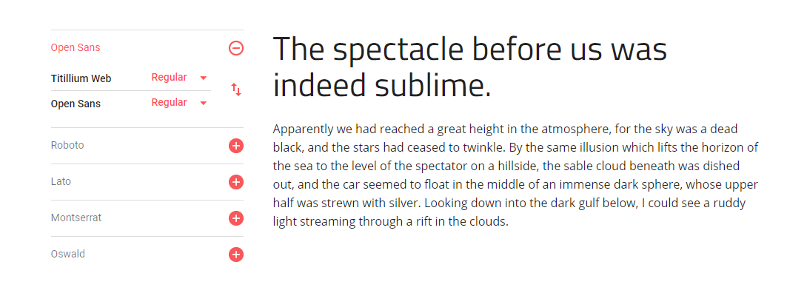

**Colour combo**

**Low fidelity wire frames**

**Wire frame 1:**

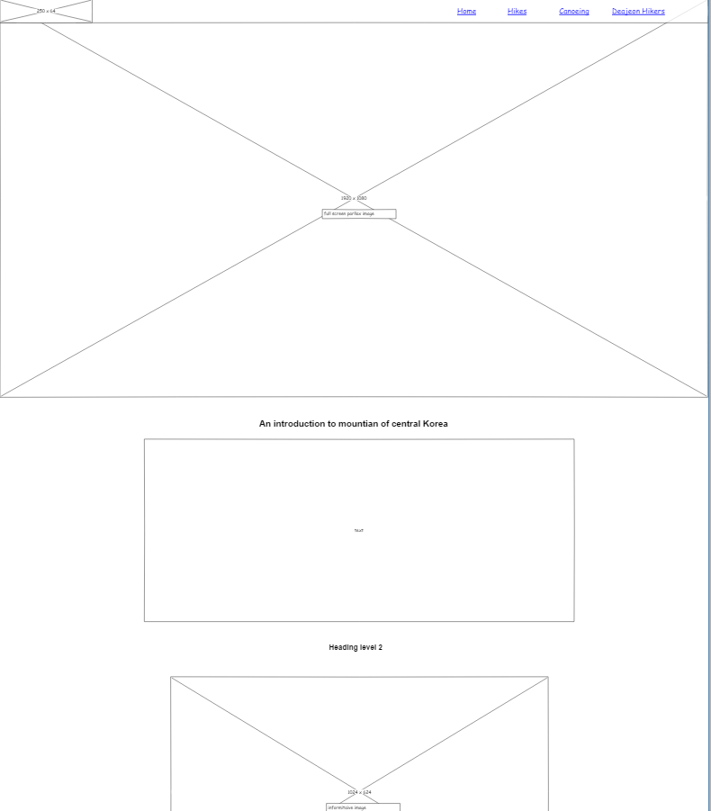

**Feedback received:**

* The images are too big and covering most of your page. I like the parallax. Your footer is too big for your lack of content.
* Banner image as well as the navbar look nice and would be easy to scale for mobile. Parallax images look nice but some of the images are too big. Footer has quite a lot of empty space, could use some extra content. Could in some cases combine parallax effect with the h1 tag to reduce very large page height.
* David – Nice use of white space and divs on multiple parallax images. Links on nav links seem far away from links. Footer seems very asymmetric.

**Wire frame 2:**

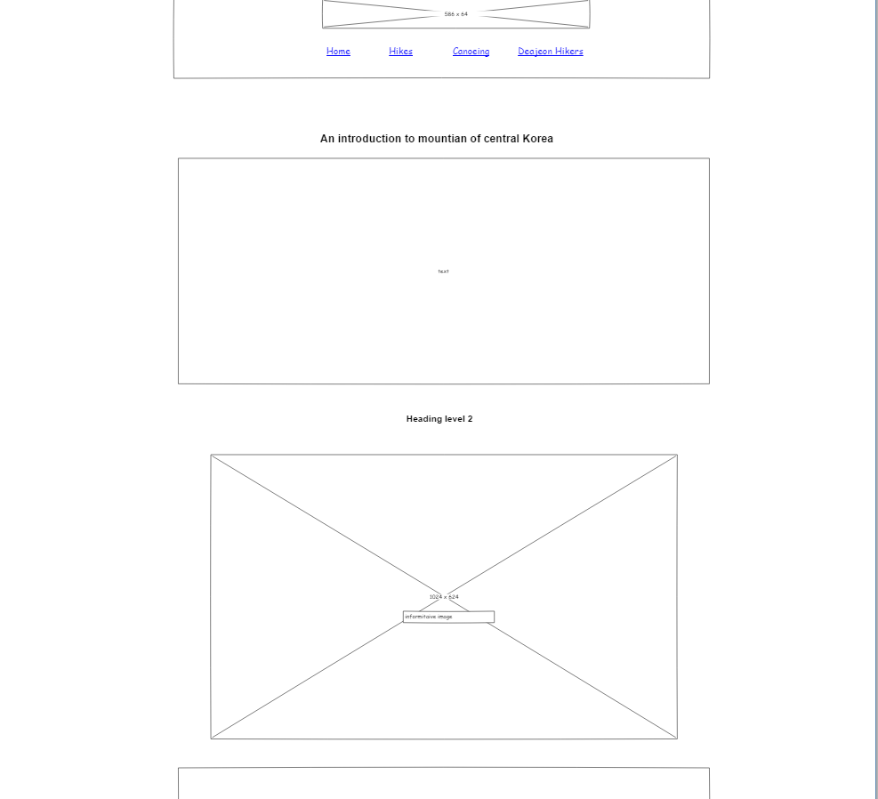

**Feedback received:**

* David - Lots of content. Imagery covers most of the page. Nav bar appears really pushed in.
* Jack – Navbar doesn’t work well being centred. Also, image looks really stretched. Lots of images that seem random. Lots of dead space in footer. Image slider that is not on other page is a good idea

**Response to feedback**

* Overall design 1 has much better feedback especially around the nav bar therefore for I will keep design 1 with some updates to the feedback
* I received feedback saying that my images were too large. So, I reduced the size of some of the images where possible
* I also received feedback saying that footer was too big. So, I reduced the height of the footer in order to reduce white space
* I also reduced the spacing between the links a little bit
* I also am considering adding the image slider that received positive feedback to replace the top parallax image on design 1 or add it to another page where more images could be required

**Changed low fidelity wireframe**

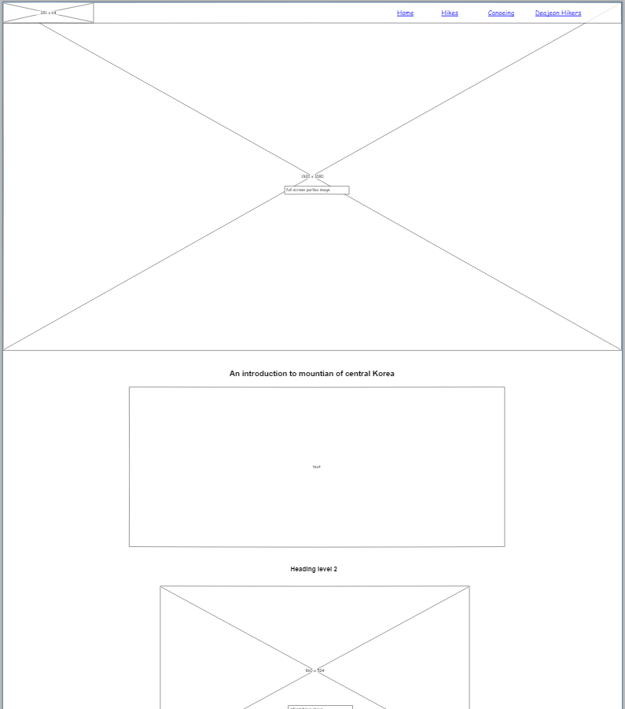

**High fidelity wireframe**

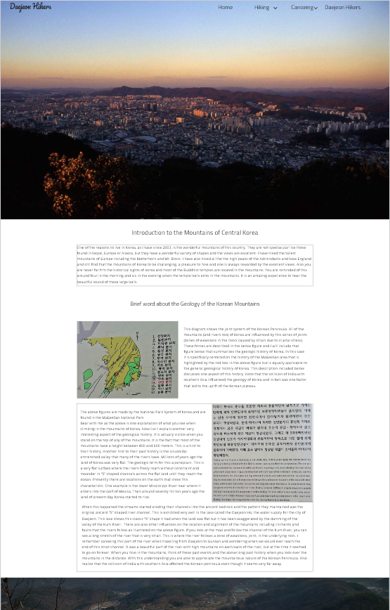

**Step 4: Protype/ Testing**

**Evidence of iterative improvement**

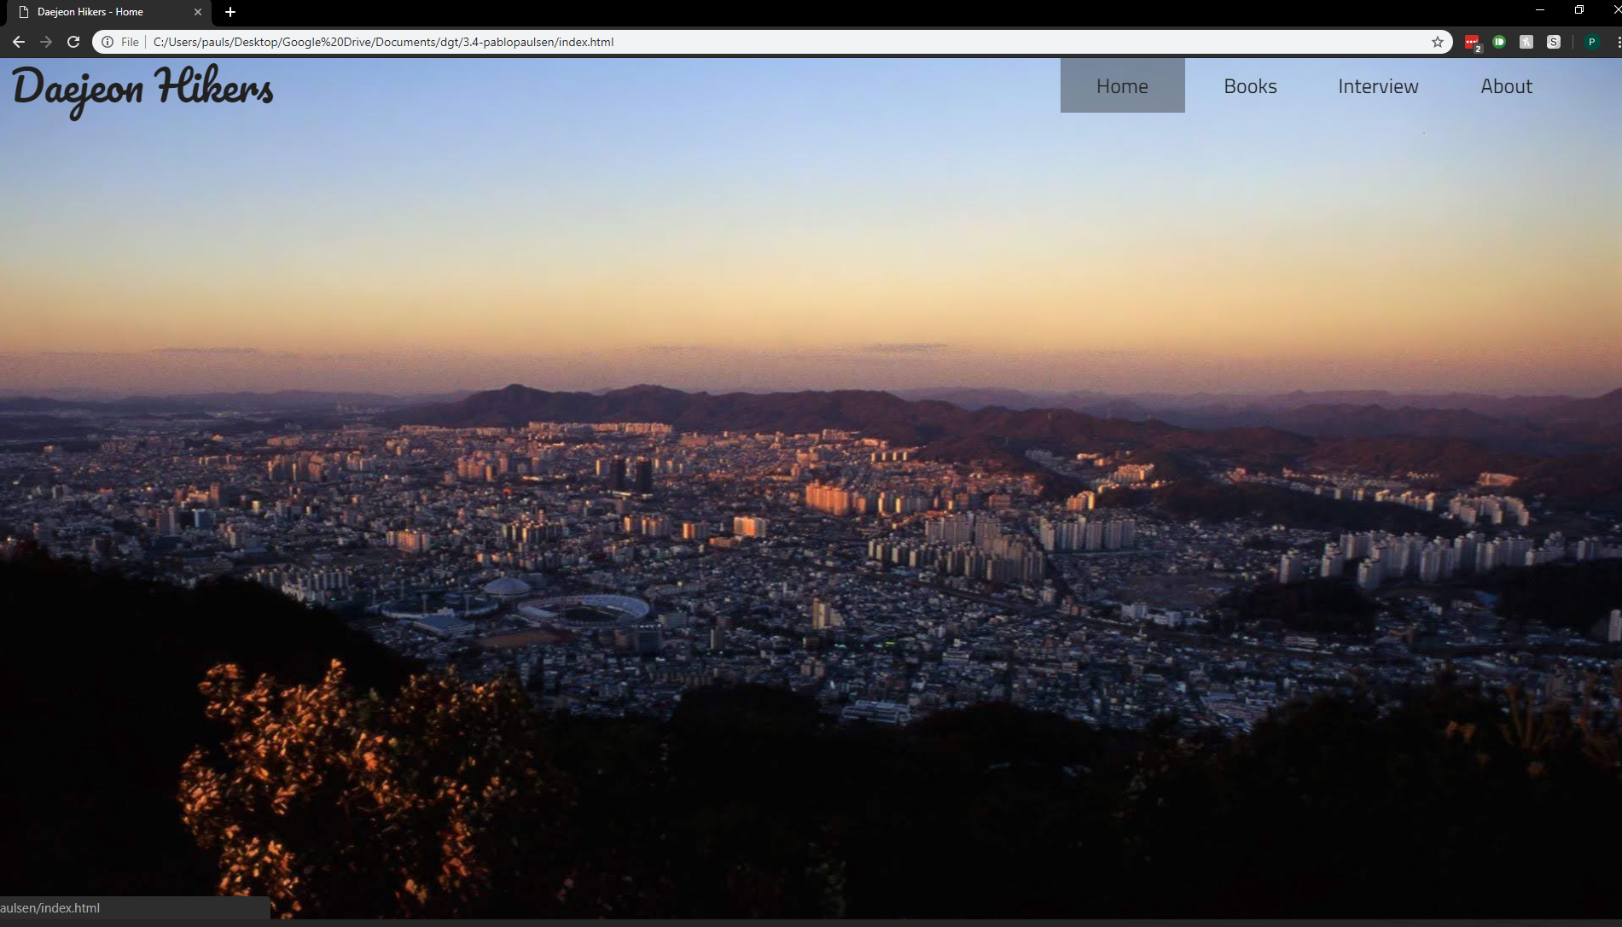

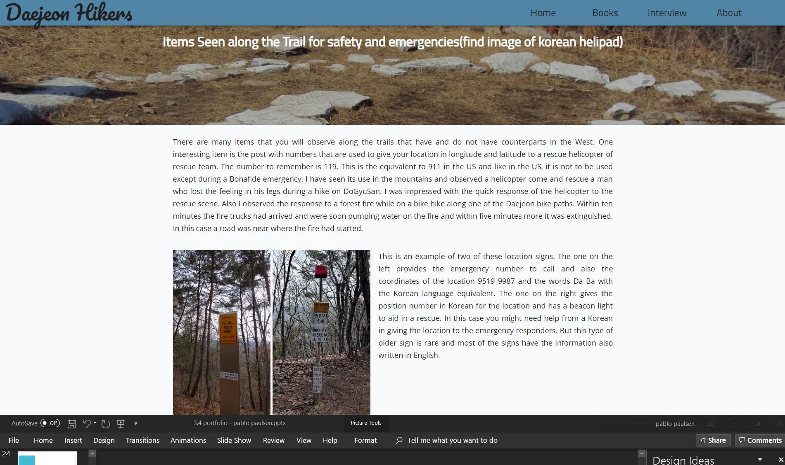

**Feedback**

* Jack Olsen: Navbar has good font choice, however I would change the hover effect. The grey block behind it doesn’t look good with the image. A lot of empty space in some of the paragraphs with images. In mobile view it would be nice if you had a sticky nav, as the top nav disappears and to go to a new page after scrolling to the bottom you would have to scroll all the way up. Maybe you could have a scroll to top as the page content is very high.
* **Zac**
* I am concerned with the white space
* Lots of writing and in some cases no breaks for long time
* I Like the parallax effects and hover effects.
* Maybe have a h2 or h3 heading as the top with space below to reduce your whitespace.

**Response to feedback**

* I changed the hover effect of the nav bar links so that instead of background colour change text colour changes
* I also change the mobile navbar so that its position is fixed
* Will be testing and comparing a new card layout for the content in order to reduce white space

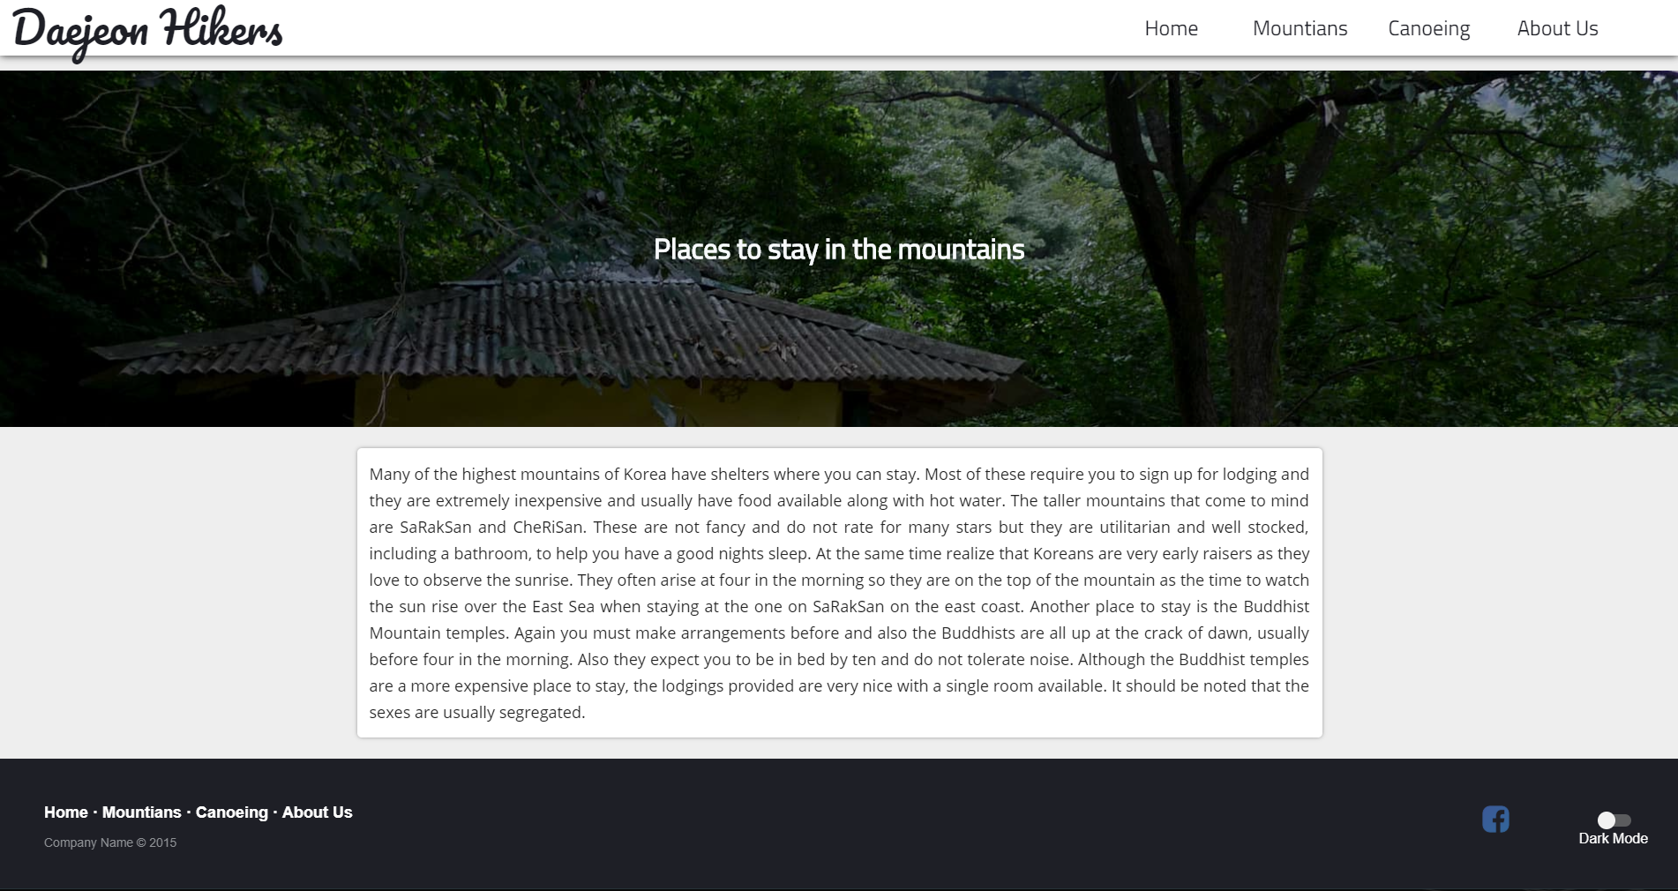

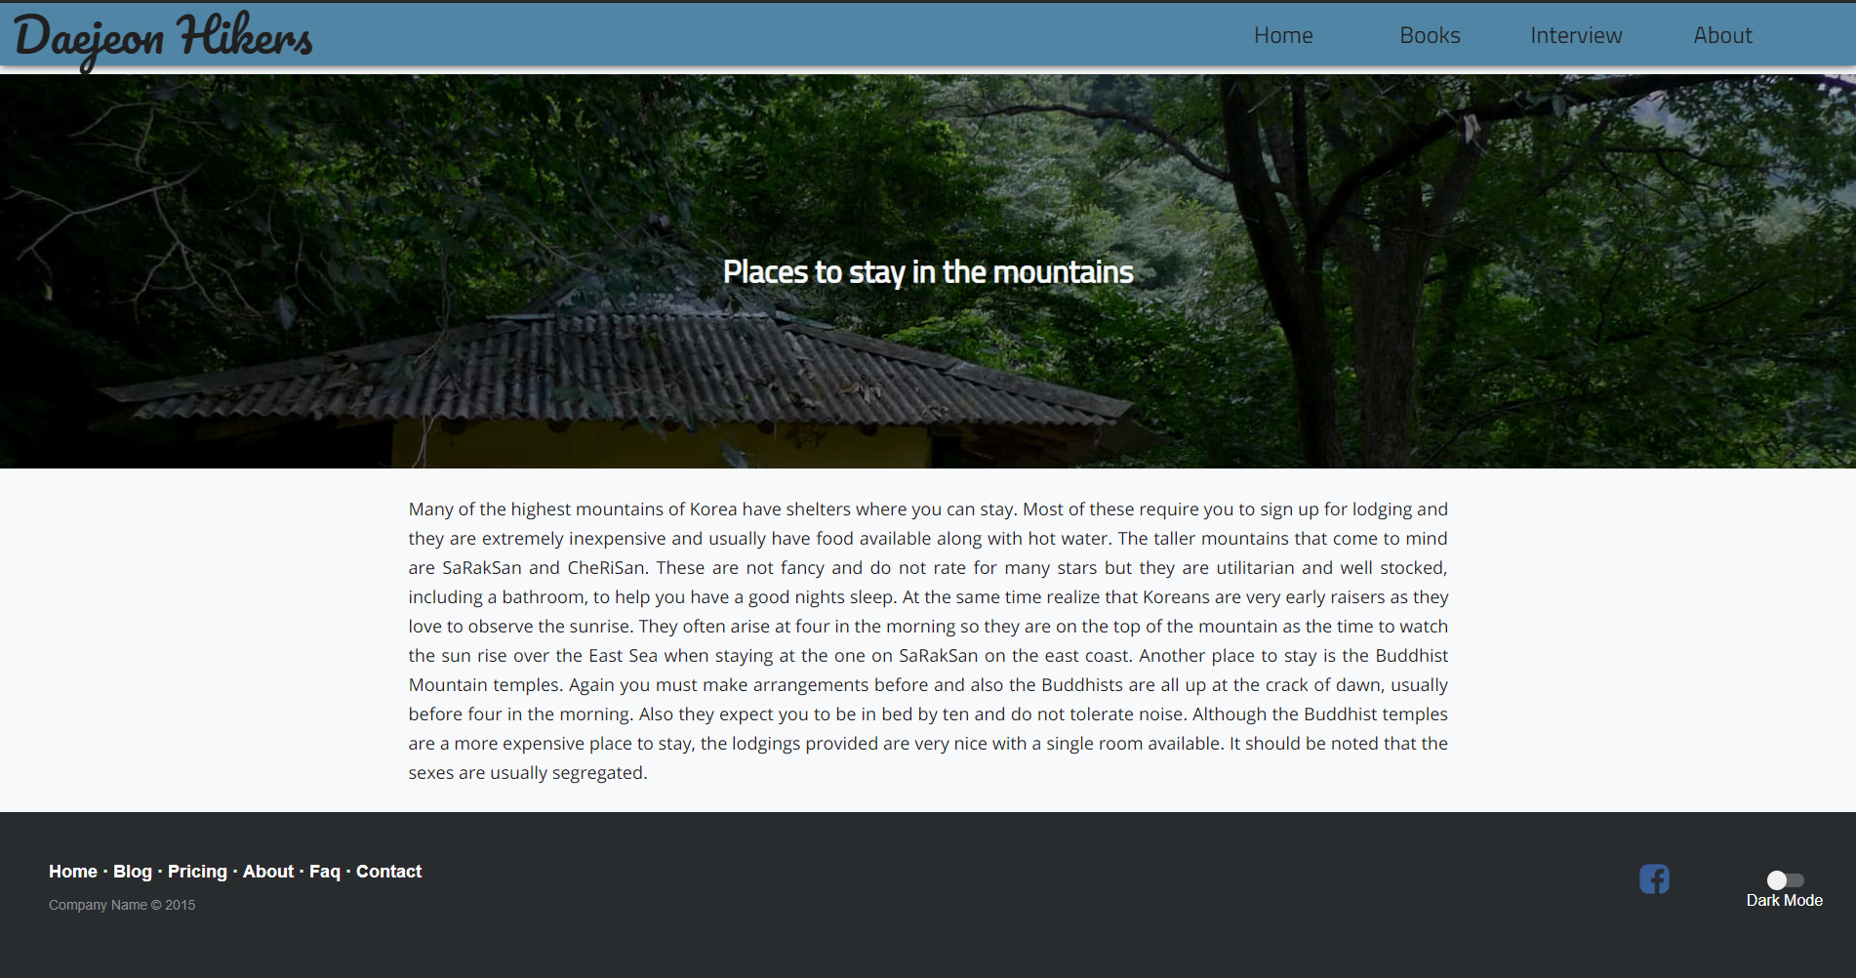

* Abdu
  + I like the page that has cards. The only thing about the card it that the text seems a bit too close to the edges of the card
  + Your font doesn’t seem to fit the title font and seems a bit off.
  + The second page has a very plain colours whereas the first page has more than one accent colour.’
  + I like the h1 tag colours. It’s not too dark and it’s not black which makes it stand out more and less at the same time.

**Response to feedback**

* as the card layout had more positive feedback, I will keep the new card layout
* Made a more even 24px padding on the content cards to space out the text and images on the card better

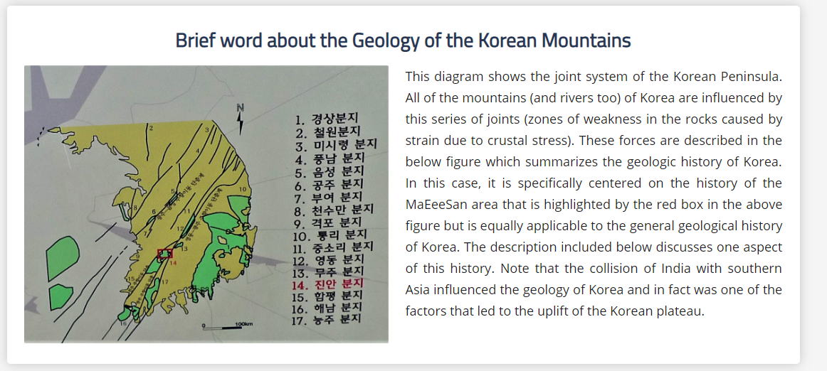

**A vs B testing: headings**

* A

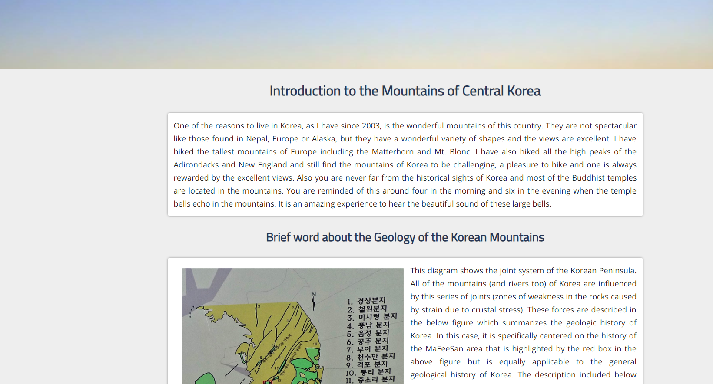

* B 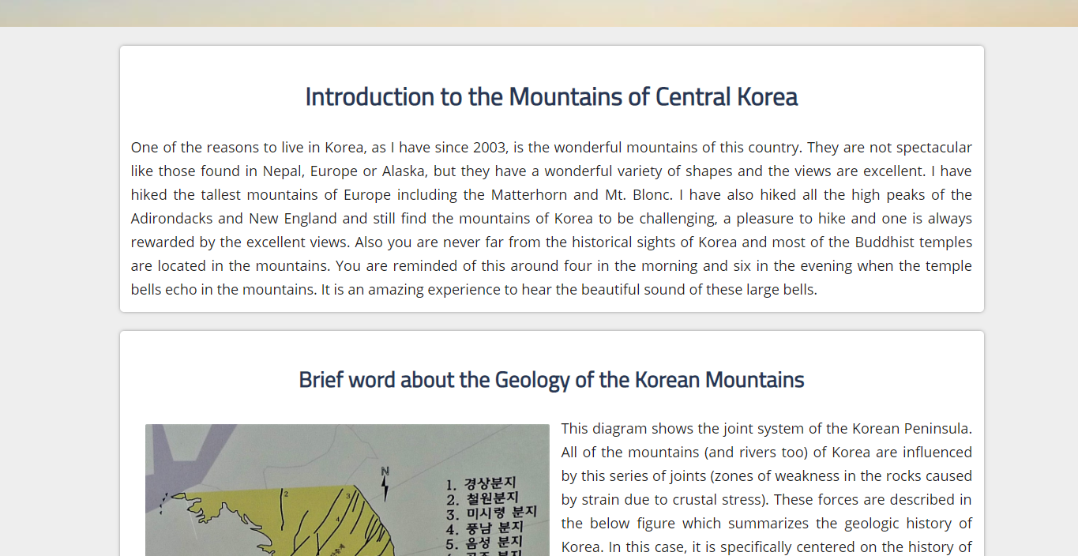

**Feedback**

* Abdu
  + I like the page where the header is inside the card.
  + If you were going to put the header outside the card, you should move the header closer to the card.
  + Add more padding above and below cards and text.
* Jack
  + Paragraph text looks a lot better with the header in the box.
  + Add more padding below and above the cards.

**Response to feedback**

* I received more positive feedback on when the heading is inside the card therefore, I will keep this design
* I spaced out the padding around the card and text

**A vs B testing: footer**

* A



* B



**Feedback**

* + I prefer the top footer. The copyright statement under the links with the lighter grey text is well done. Compared to the black copyright statement under the Facebook link. The white text on dark background is very professional looking. The Facebook logo could have a white f maybe.
  + I also prefer the top footer. The text colour of the bottom footer seems a bit too dark. The gap between the dark mode icon and the Facebook icon is quite large. You should add another icon with the Facebook logo, because one just seems a bit lonely

**Response to Feedback**

* As the top footer with the copyright text below the links received better feedback, I will keep this design
* As there is no other social icons that my client requires I cannot add any other social icon. I however did replace the icon with a white only icon done by SVG. This improves loading time compared to an PNG as no image is required to be downloaded and fits the design of the other elements in my footer better and I also moved it closer to the dark mode switch in order to make it feel less “lonely”
* 

**A vs B testing**

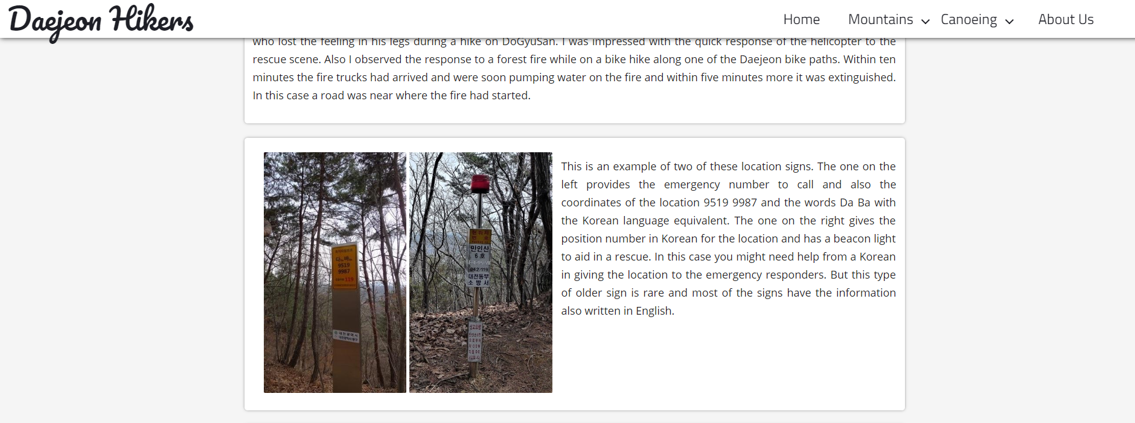

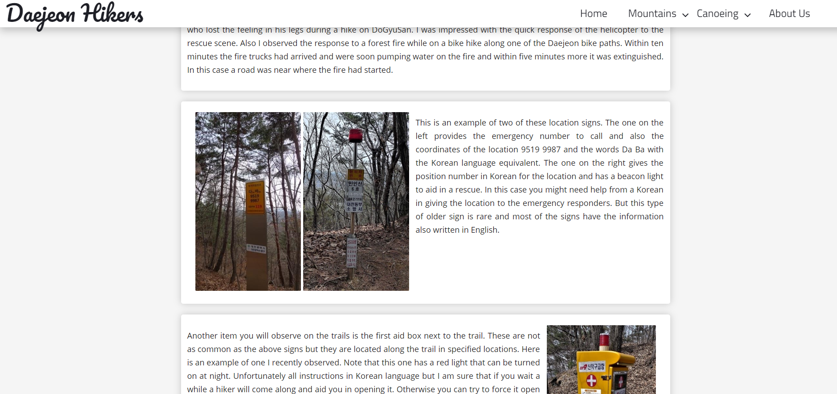

**Feedback**

* Zac

I personally prefer the shadow of the bottom image. As it gives a clearer separation of the nav bar and the content. While on the top it is more difficult to see. moreover I see that the J in the image on the top left goes past the shadow slightly, which to me looks irritating when compared to the other.

**Response to feedback**

* As the bottom shadows were preferred, I replaced the old thinner darker shadows with the lighter shadows with more blur

**A vs B testing**





**Feedback**

* I personally prefer the bolded text over the non bolded text as it makes it more easily to differentiate over the normal text. And I just like it, As the other one has the text harder to read when having a white background,

Zac

* I personally prefer the bold nav bar. I like the bold one because it is easier to read and it stands out more from the background. It also suits the ‘Daejeon Hikers’ font colour and Font weight.

Abdu

**Response to feedback**

* As the bottom bolder font has better feedback including saying it makes it easer to read the links and suit the design better, I kept the bolder nav bar links

**Initial design of dark mode**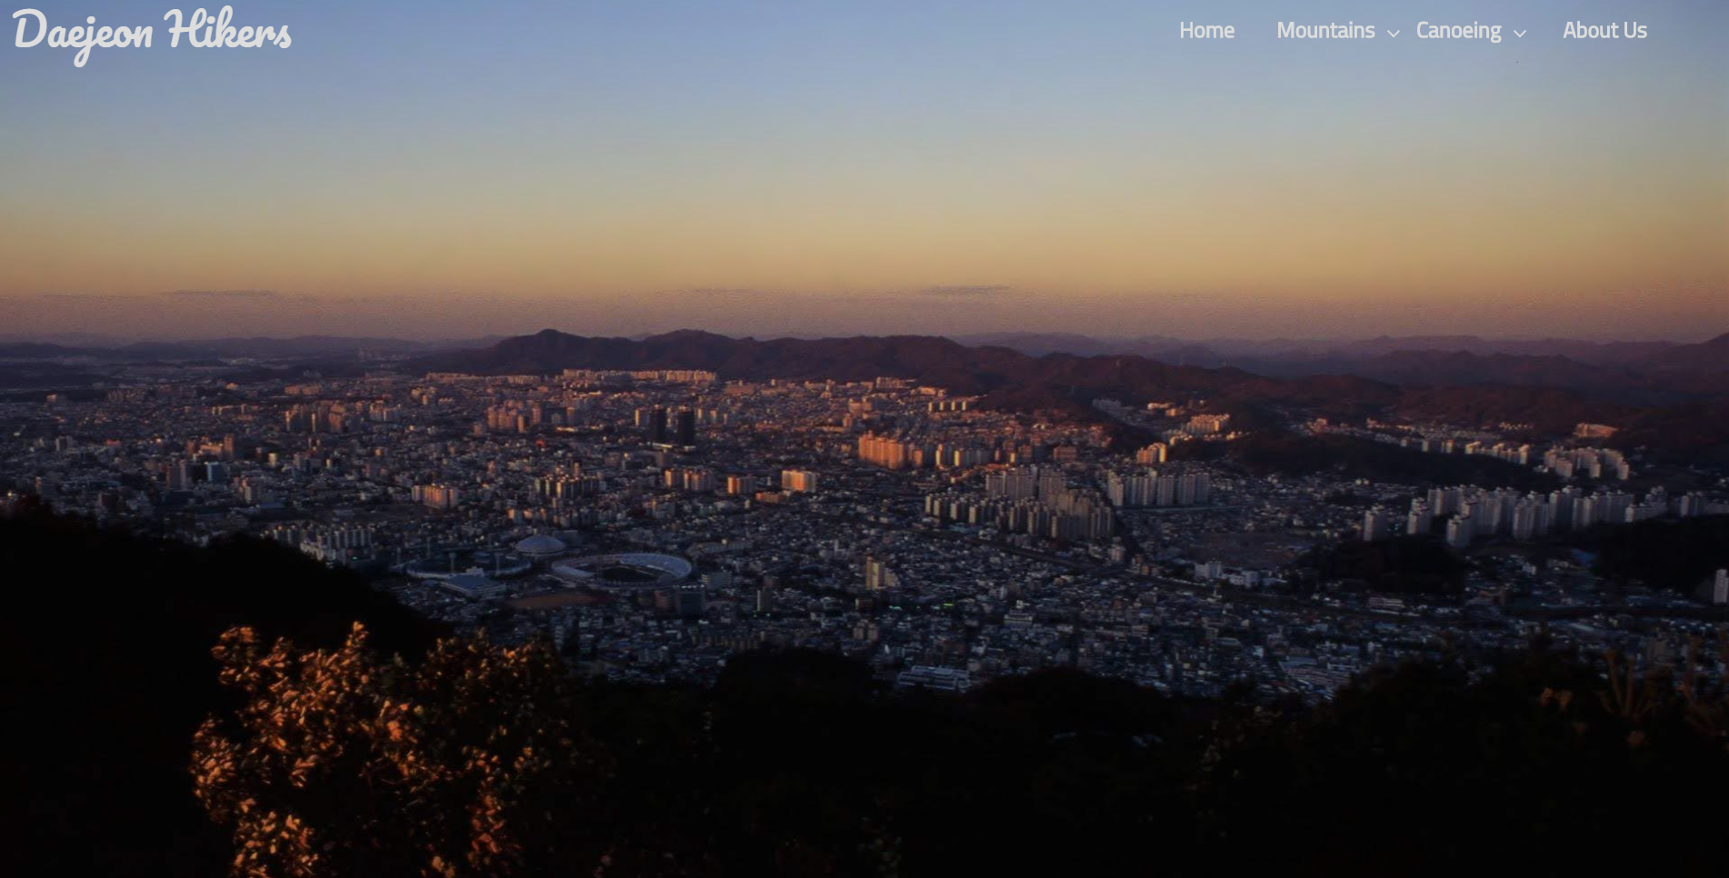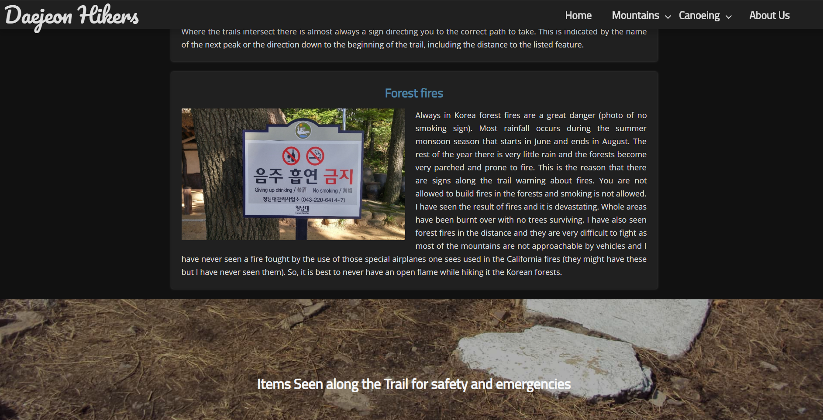

I used JavaScript with cookies so that even when the user leaves the page or goes to another page dark mode does not disable. This is as a dark mode that disables every time you reload the page or even go to another page within that page would be useless. Therefore, it would not usability heretic accessibility, **Accessibility** as it would not help people with more sensitive eyes avoid bright light.

**Feedback**

* I find it hard to read the text in the nav bar as it is easily swamped by the background. However, in dark situation I would prefer this over a lighter theme. Meaning that is an essential part in the accessibility of a usability heretic. -Zac
* The main nav text colour I a bit hard to read. The blue of the main header titles seems a bit off from the main. The page has more contrast from the background. -Abdu

**Response to feedback**

* I received feedback saying that the links were hard to read even with the darkining filter over the parallax image on when dark mode is enabled, I will therefore get more feedback over what colors are preferable for the nav bar
* I also received feedback saying the blue h1 and h2 on the dark mode page does not suit. I will therefore get more feedback in order to determine the correct color

**A vs B testing**

**A**

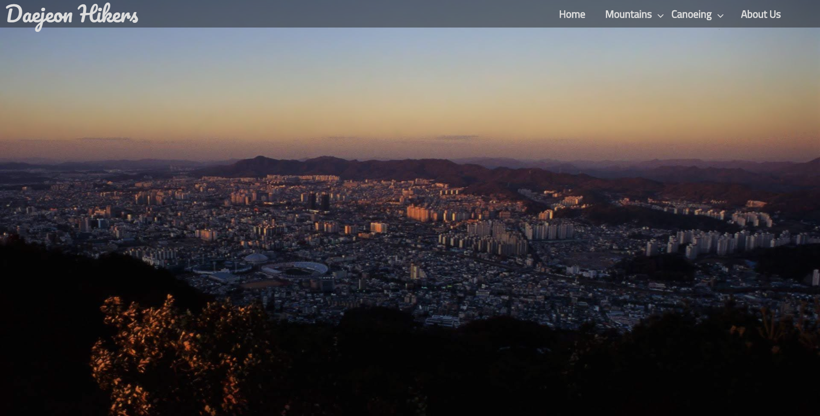

B

**Feedback**

* I like the ‘A’ nav bar. You can read the text more easily and if feels cleaner. The text can be read more easily since its more contrasting in A

**Response to feedback**

* as my scroll function is made so that it can accept any initial and final RGBA value and use that to automatically find the appropriate color using an equation based on the scroll position I changed the site so that when dark mode is enabled the initial RGBA values are so that it is semi transparent to allow for better readability

**A vs B testing**

**A**

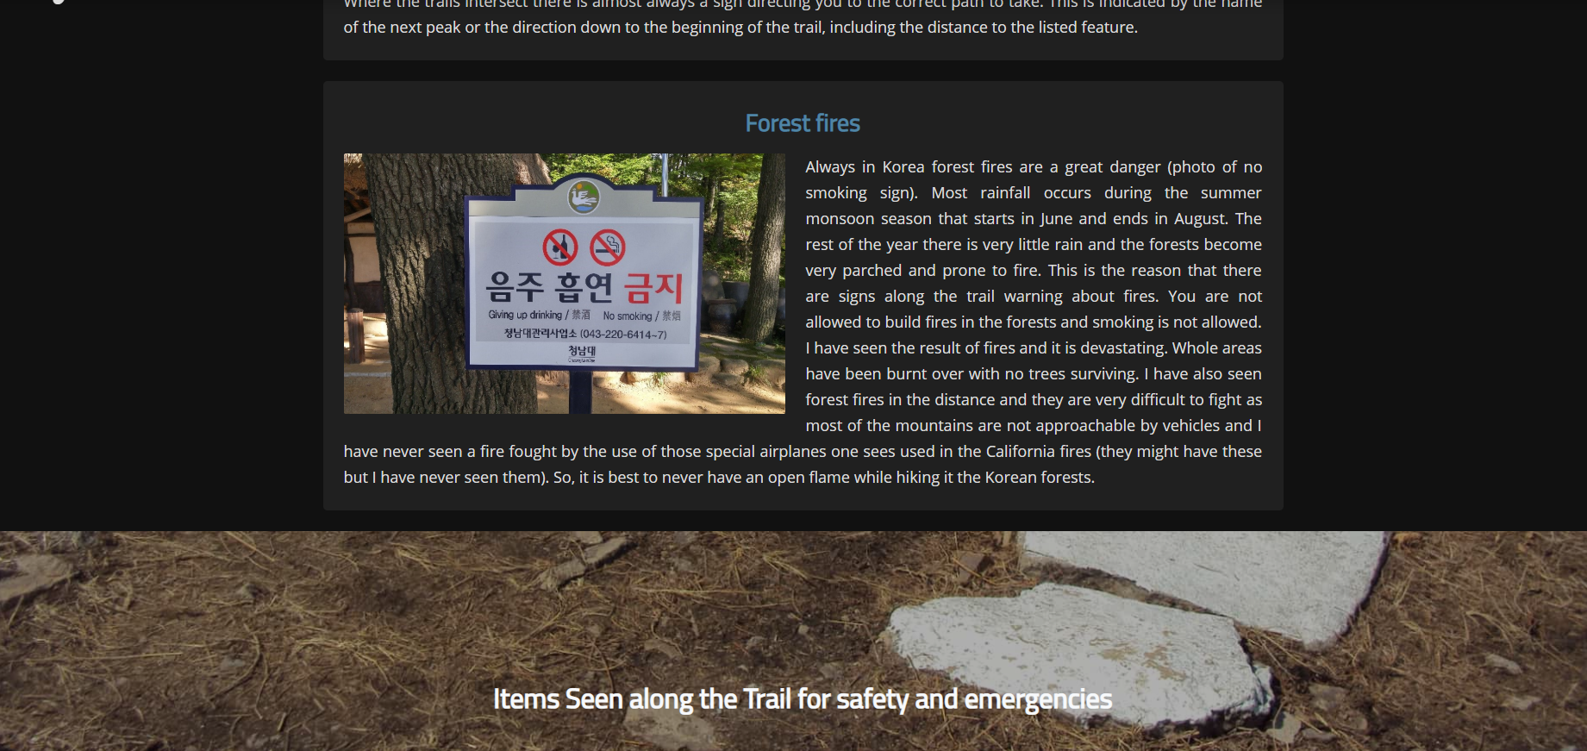

B 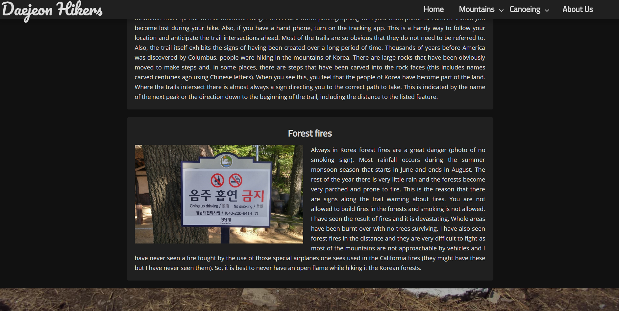

**Feedback**

* The title in B fits in more with the rest of the page. I like B more because it has greater contrast than A -abdu
* The blue in the heading looks out of place and does not suit colour scheme – zac

**Response to feedback**

* As the white heading received better feedback i change the heading on my page to white from the previous blue color

**Initial Dropdown menu**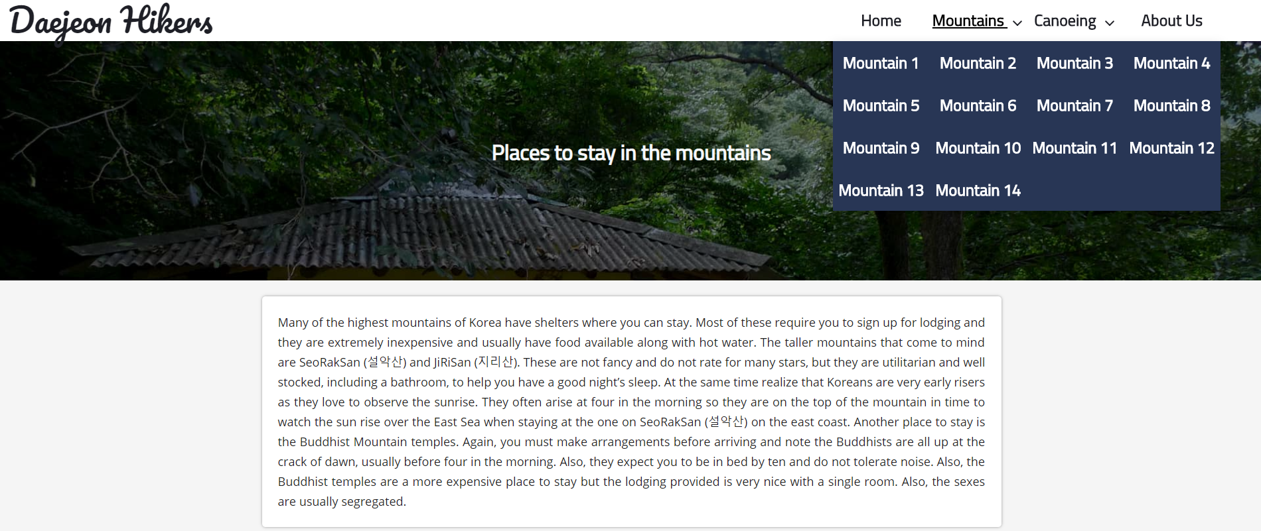

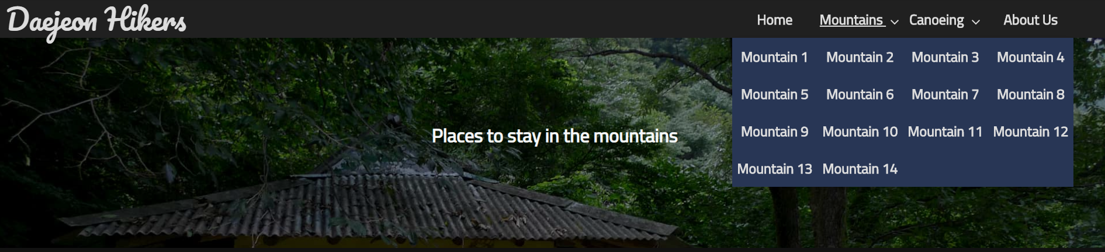

**Feedback**

* I don’t like the colour it should be something else that matches the top of the nav bar. I don’t the underline under the mountain. Maybe just must animate to a different colour such as grey. Zac
* The drop down is too wide, and it feels more like you are picking from a lot of text. The colours of both the top and bottom don’t fit the rest of the page. -Abdu

**Response to feedback**

* As I received negative feedback on the colour of the drop down menu, I made the colour to match the top nav bar as suggested the person giving me feedback
* I also changed the hover effect of the nav bar link from the under lining of link text to just a darkening in light mode and lightening in dark mode of the link text so that it stands out more

**Initial design of mountains page**

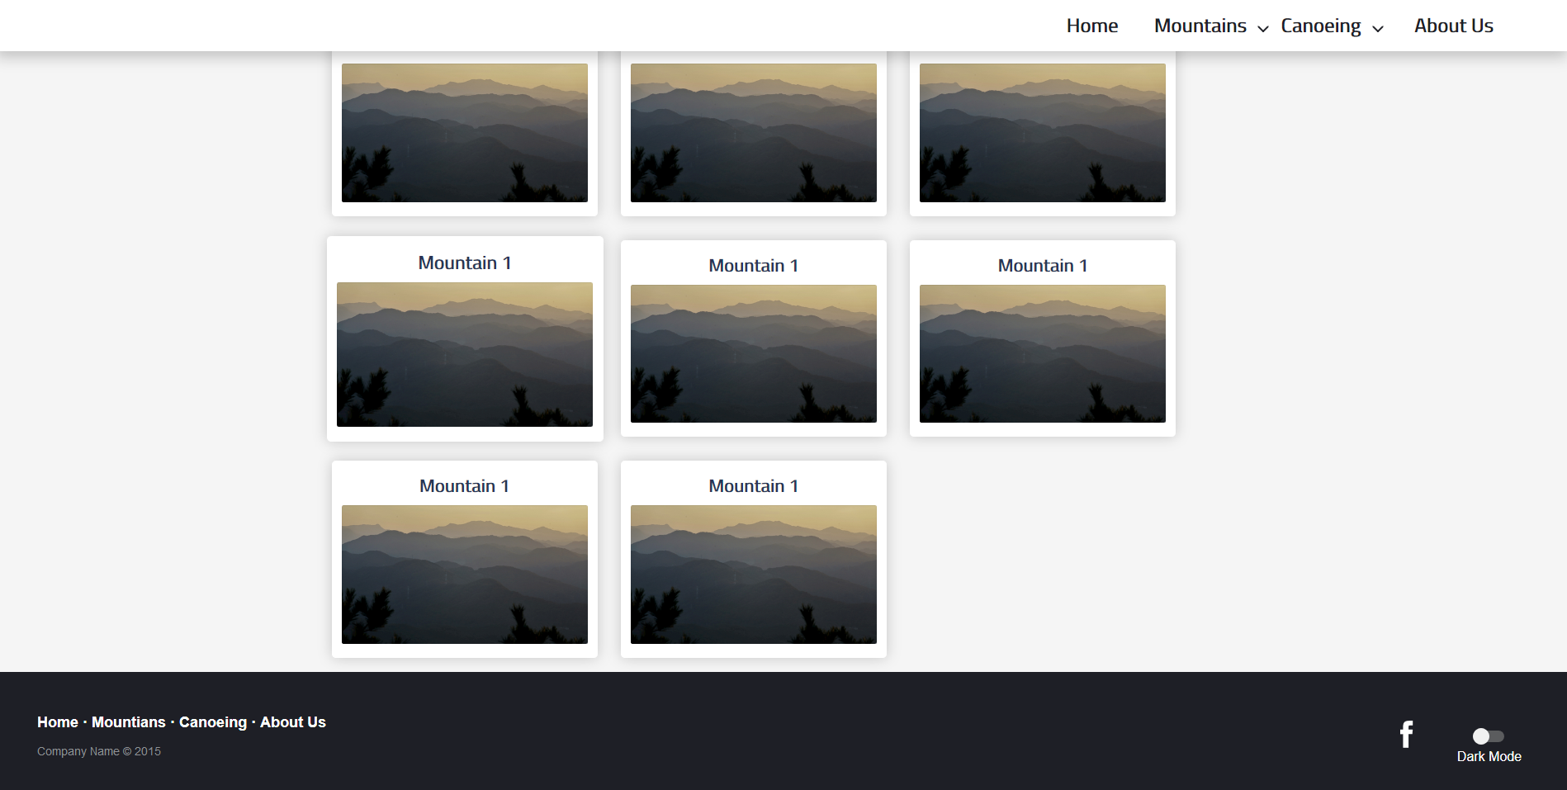

**Feedback**

* The image container looks modern. However, the bottom two are not centred which looks a bit odd. The animations on hover also look quite modern and elegant. -abdu

**Response to feedback**

* I received positive feedback on the card layout for the mountains where each mountain page will get its own page.
* The scaling animation on hover also received positive feedback as it looks “modern and elegant” so I will continue to use the same animation on hover
* The 2 none cantered ones at the bottom received negative feedback as they are not centred, I therefore used the display: flex in order to have better flexibility on the page. This is important for relevant implications **Future Proofing and sustainability** as this page will be continued to be updated and therefore having more flexible code is always required

**Testing Procedures: performance**

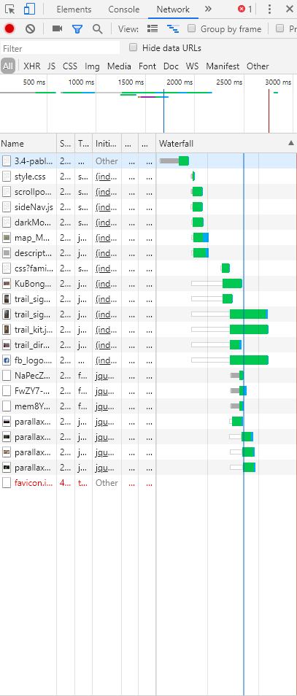

* I hosted my website using git hub in order to check the loading speed and any files that may take longer to load. As all my files are compressed Loading time was short and only 1.9mb was downloaded which means even with a 5mbps internet connection the site should only take 4 seconds to load
* 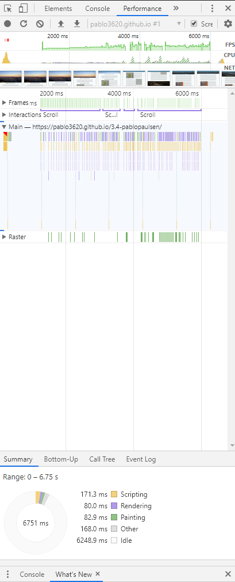
* I then check performance and noticed some frame dropping and computer fan spinning up. If hardware acceleration is disabled, this becomes worse as I experienced frame rates below 15fps. As some people do not use hardware acceleration, I need my website performing well for these users. In order to find the cause of the issue i used chrome developer tools and found that my scroll function was taking very long time to change the style. After some testing I realized that my parallax image blurring as you scroll was causing the performance issues, so I disabled it.
* 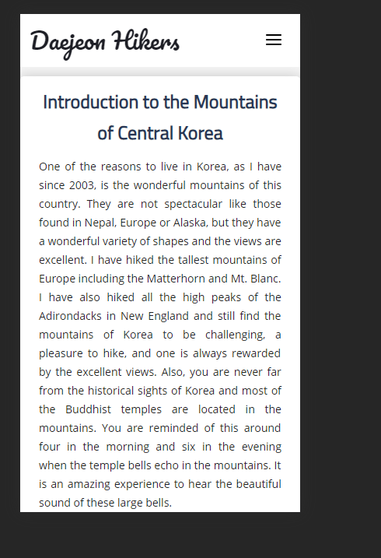
* 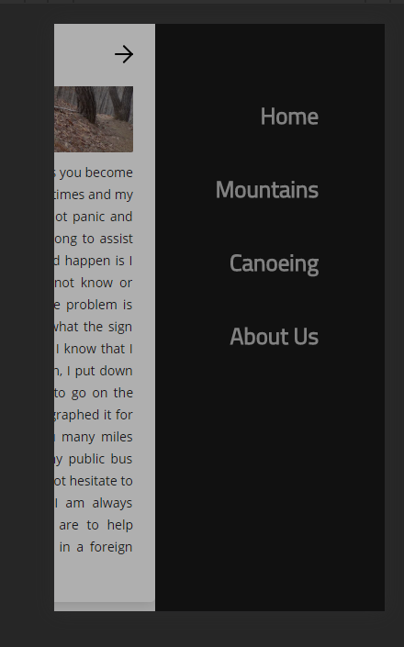

As I have the website hosted on GitHub, I can easily test it on my phone for as chrome developer tools for mobile is not 100% accurate of how a page is displayed on mobile. However, chrome develop tools is still useful. An example of this is the parallax effect is still visible on chrome developer tools while does not exist for mobile. Therefore, when testing my mobile page it should be tested on a mobile phone not on the chrome developer tools.

**Feedback**

* The links are too dark. They are not very easy to read.
* The nav buttons along with the animations that follow look very nice.
* The card design looks minimal design.
* The open nav is convenient since it is fixed to the top of the page. More accessible.
* Compared to the desktop, the webpage on mobile very similar to the desktop. This is very consistent
* Single column of the desktop nav bar looks nice

**Response to feedback**

* as when making the mobile site I kept the same design but made it single column with the mobile nav bar not much has changed design wise
* the mobile nav bar and its animation received very positive feedback except for the links which were slightly to dark and therefore had a negative effect on readability. Therefore, changed the colour of the nav bar links to be a lighter colour
* the full width cards had positive feedback so I will keep this design
* I also received positive feedback on the nav bar as nothing has changed from the desktop page except for making the content single column

**Addressing relevant implication**

**Aesthetics**

* In order to have a Modern and aesthetically pleasing nav bar I used hand writing style pacifico font for the banner logo placed to the left of the nav bar and titillium bold font for the links to the other page sites. The nav bar is links is a very dark navy blue colour rather than a black colour as this design received positive feedback and as it suits my colour palettewhen the scroll position is at the top of page I made the nav bar become transparent so that it give less visual distraction form the full screen parallax image. This become white when the page is scrolled down to the content so that the readability of the links is not affected by the text on the page and using the shadow to give the impression that the nav bar is on top of the content.
* For my content I used a card layout. 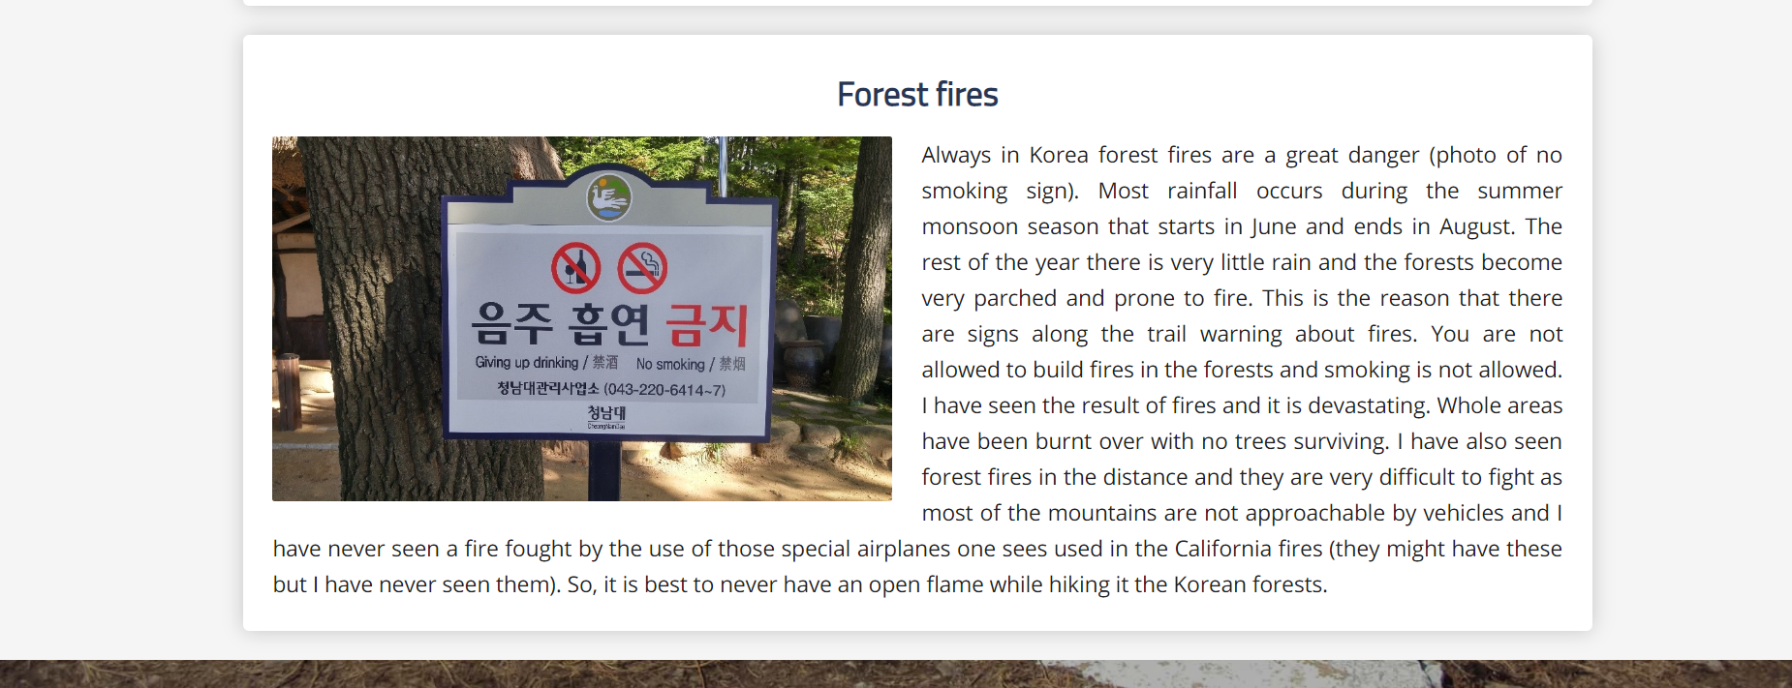in order to have maximum readablity I made that background color of the text on the card white. In order to clearly show the card layout I made that background color of the body to an off white with a hex value of #f5f5f5 and added a shadow to the card. I used an off black color for the text as it is more comfortable when reading than a pure black text. This card layout is good as it makes it easier to separate content in order to separate the long text which would be boring without seperation. In order to further separate the large amount the text to make it more asesthicly pleasing and less boring I also added images within the contnet card relateing to what the text is talking about. Every so often when the topic changes I also added a smaller parallax image with a heading within it. In order to make sure the page is not cluttered I added a 24px padding around the contnet witin the card and anthoer 24px margin between the content card while keeping the content card centred so that there is enough white space around the content to no feel cluttered.
* I also used the rules of thirds where the top 1 screen worth of height of the page is the nav bar and the full screen parllax image with an arrow indicating the user to scroll down where the user will see the middle section of the page, the content. Here the previously mentianed card layout of the content is used to display the content. At the bottom of the page I have the footer containing the links for the pages and a copyright statement alonge with socail mediea links and an dark mode switch
* In order to have good aesthtics on all sized devices my page is scalable with a desktop page and a tablet/moblie page and different sized fonts for desktop tablet and moblie devices.

**Accessibility**

* My page is saleable across all types of devices. This helps users with different devices all use the page and therefore increases the number of users that can access the page and therefore improve accessibility
* on all the images on the page I included alt tags. This help blind users use the page and users that may have extremely slow internet and therefore unable to load the full page still load it to a level that is useable and therefore making the website more accessible. The alt tags also help with search engine exposure also making more accessible for more users.
* I also made my hyperlinks obvious and changed the curser to pointer when hovering over them in order to make the site easier to understand and therefore more accessible to more users

**Future proofing and sustainability**

* In order to make my website easily fixable by another person I added code comments to my code so that it is easily modified in the future and therefore making my website more future proof.
* I also made much of my CSS and JavaScript as reusable as possible so that if new content is to be added I do not need to code any new CSS or JavaScript and only need to code the simplest from of HTML code. Examples of this is if a content card is too be added the coder can just copy the standard form of a content card from the file I made called note.txt and just add the title of the card, the links of the image, and the text and then select if image should be right or left by adding the class left or class right to the image. In my scrollpostion.js even thought could have only changed the opacity according to my current initial design I coded it so that it could accept any initial and any final RGBA value for the colour. This did come in use as during the iterative design process I received feedback recommending me to change the initial opacity of the nav bar in order to improve readability. As my JavaScript was designed to be very flexible and therefore future proof this opacity changes only required the change of 1 variable number. I also did a similar process with my darkmode.js as it would be easier to just use the JavaScript to change the style whenever dark mode is enabled or disabled I instead added by JavaScript class “dark” to the body so that if the client or another coder would like to change the style of the dark mode this can be done easily via the CSS file.
* I also when aligning my mountain page links, I used the CSS property flex. This allows for the page to have a non-Multiple of 3 number of mountains while this links still being centred. 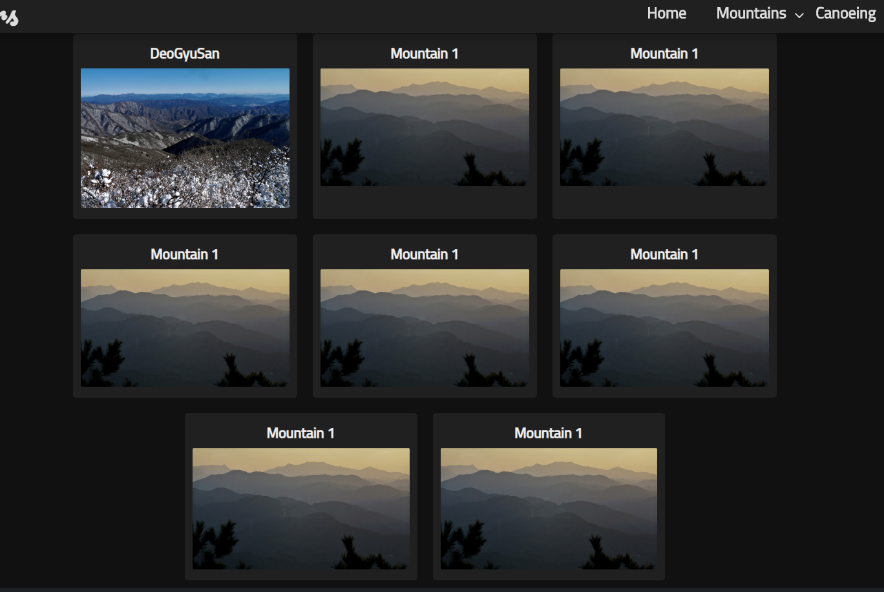this allows for more flexibility for the page and therefore allows it to be more future proof.
* I also used the most up to date CSS and HTML versions.
* I also did not use any plugins. This means that no part of my website is controlled by anything else beside the code that I wrote and therefore support for a certain plugin end I could use would not end up breaking my website allowing the website to be more sustainable.
* In the footer I also added a copyright statement for me along with the year so that the client or someone else can content me